Practical 10: Secure Login/Logout with Sessions, Role-Based Access, Timeout, and Remember-Me Token
Problem Definition Develop secure login and logout functionality using PHP sessions. Verify
password using password_verify(), regenerate session ID after login,
restrict dashboard access, implement role-based redirection, session
timeout, and optional secure remember-me token.

Theory :

Key Questions / Analysis / Interpretation
1. Are sessions started and destroyed securely?
Yes. session_start() starts the session, and session_destroy() destroys the session during logout. session_regenerate_id(true) generates a new session ID after login.
2. Is password_verify() used correctly?
Yes. The password_verify() function checks the entered password against the hashed password stored in the database.
3. Is unauthorized dashboard access blocked?
Yes. The dashboard checks whether the user is logged in. If not, the user is redirected to the login page.
4. Is session timeout implemented?
Yes. The session expires after 15 minutes (900 seconds) of inactivity when the user makes another page request.
5. Are admin and student users redirected to appropriate dashboards?
Yes. Admin users are redirected to admin.php, while normal student users are redirected to dashboard.php, based on their role stored in the database.

Implementation/out put/result:

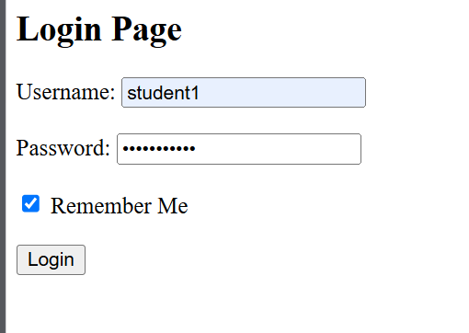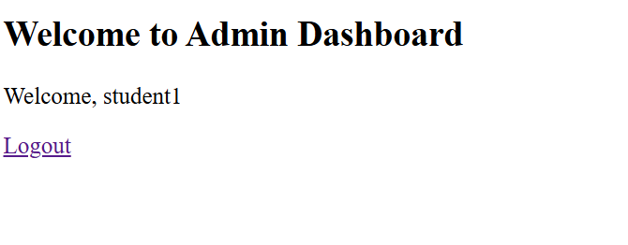
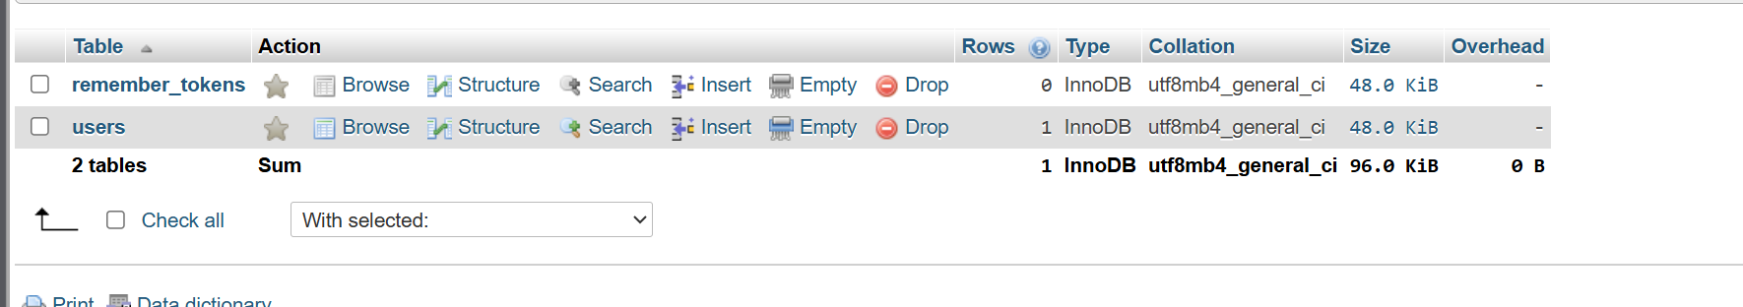

Git hub link:
https://github.com/nidhisavalia/25dce103-web

Learning outcomes:

Learned to implement secure login and logout using PHP sessions.
Learned to verify passwords using password_verify().
Learned to regenerate session IDs after login.
Learned to restrict dashboard access to authenticated users.
Learned to implement role-based access control.
Learned to manage session timeout and logout securely.

Faculty remarks:

